LAB #3: Structural Efficiency 2.0
Materials:
- 4 sheets of Newspaper (to start) - 60 cm Masking Tape - Glue - Scissors - Weights
Objective:
To build the most efficient table from newspaper
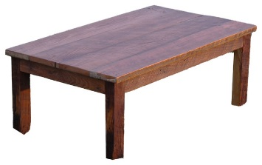
Criteria:
Minimum height = 20cm
Maximum height = 30cm
Procedure:
1. Create a design plan with sketches (3D if possible).
2. Construct your structure.
3. Test your prototype.
4. Identify and make improvements.
5. Calculate the mass of your final structure.
6. Test your final structure!

Design Plan & Sketches

Review:
1) How did you decide on what to build?... Research?... Trial and Error?... Copied Someone Else’s?... Guessed?... _______
__________________________________________________________________________________________________

2) Draw a diagram of your original design compared to your final design.

Original Final

3) Explain the improvements made to your original design. __________________________________________________
__________________________________________________________________________________________________
__________________________________________________________________________________________________

4) How did your structure fail? _________________________________________________________________________
__________________________________________________________________________________________________

5) Calculate your structure’s Structural Efficiency.

________________ ÷ ________________ = ________________
live load dead load structural efficiency

6) If you were to complete this challenge again, what would you do differently? ________________________________
__________________________________________________________________________________________________

7) Overall, how efficient was your structure?
0 = not efficient 1 = somewhat efficient 2 = efficient 3 = very efficient

