LAB #2: Strong ‘and EFFICIENT’ Straws
Names: ______________________________
Class: ___________
Objective:
- To design an efficient straw structure that will support a full cup of water at least 8cm off the table.
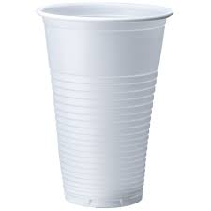
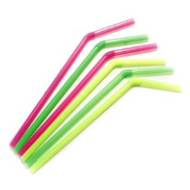
Materials and Cost:
Straws 1 straw = $1
Masking Tape 15cm = $20
Cup 1 cup = free
Procedure:
1) Plan, design, and budget…

2) Purchase and record
Material | Amount Purchased | Total Cost
Straws
Tape
 | Total Cost
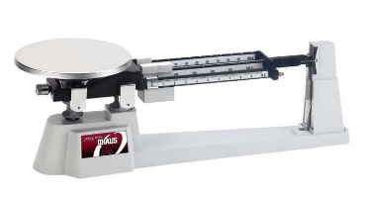
3) Build!
4) Test
5) Weigh
Our structure weighed ___________________________ grams (with the cup attached).

Review:
1a) What ‘type’ of structure did you build? ______________________ How do you know? ________________
__________________________________________________________________________________________
__________________________________________________________________________________________

2) Why/How did your structure fail? Explain ______________________________________________________
__________________________________________________________________________________________
__________________________________________________________________________________________

3) Describe, using a diagram, how you could have made your structure more efficient ( = strengthen without adding weight).

4) How efficient was your structure? Circle one.
0=not efficient 1=somewhat efficient 2=efficient 3=very efficient 4=extremely efficient

5) Calculate the quotient…… ____________________ ÷ ____________________ = ____________________
(weight in grams) (cost to build)

