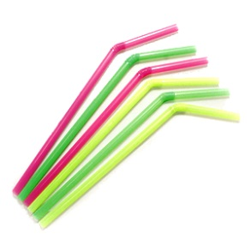
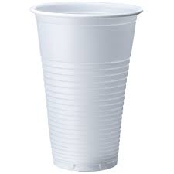
LAB #1: Strong Straws
Names: ______________________________
Class: ___________

Materials:
10 Straws

15cm of Masking Tape
Objective:
To design a straw structure that will support a full cup of water at least 8cm off the ground
Procedure:
Plan/design
Build
Test!
Review:
1a) What ‘type’ of structure did you build? ______________________ How do you know? ________________
__________________________________________________________________________________________
__________________________________________________________________________________________

2) Why/How did your structure fail? Explain ______________________________________________________
__________________________________________________________________________________________
__________________________________________________________________________________________

3) Describe, using a diagram, how you could strengthen or stabilize your structure.

4) How efficient was your structure? Circle one.
0=not efficient 1=somewhat efficient 2=efficient 3=very efficient 4=extremely efficient

